**10% OFF INSTANTLY!**

***Present this flyer at the time of purchase and receive an instant 10% off!***

***\*System may differ slightly (in appearance only) from PC pictured above\****

www.toplinetechcs.com

Copyright 2014 Topline Tech CS All Rights Reserved.

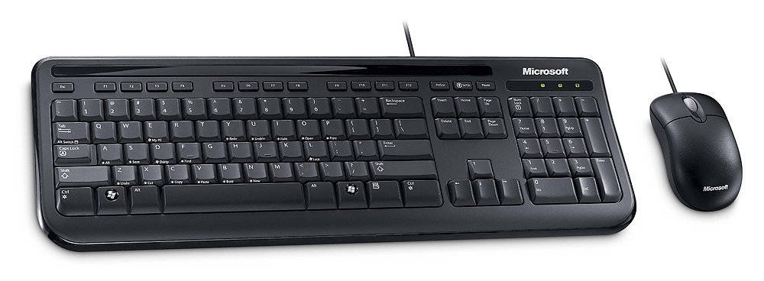

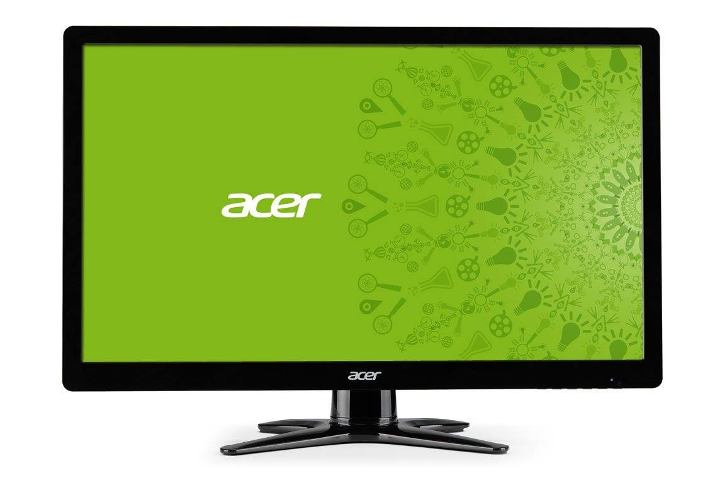

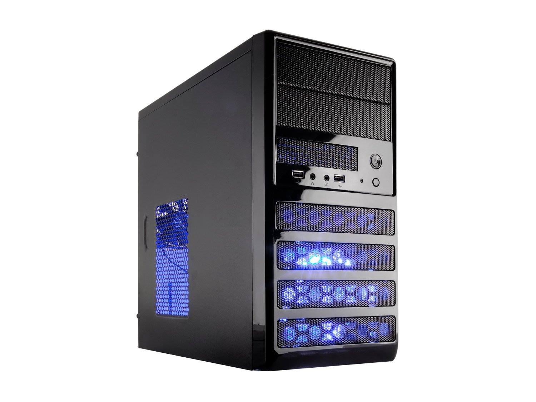

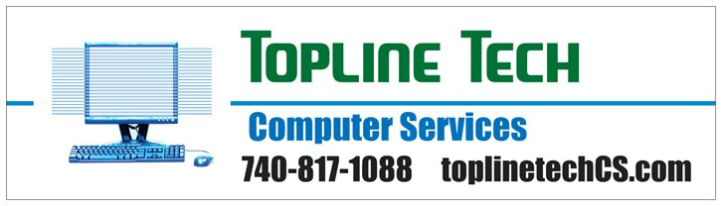

**Topline Tech T-8801 Desktop**

* AMD Sempron 3850 1.3GHz multi-core CPU
* 1 TB Hard Drive
* 4 GB DDR3 Ram
* DVD writer
* Your choice of Windows 7 Home Premium or Windows 8.1
* 20" Acer monitor
* Standard keyboard and mouse (wired)(may be different than those pictured)
* Includes local setup and delivery with 1 free hour of service for transferring files from your old system.
* 1 year limited Warranty (Extended Warranty Available)
* $749.99